Mixed-methods Research Design generated by <<Name>>
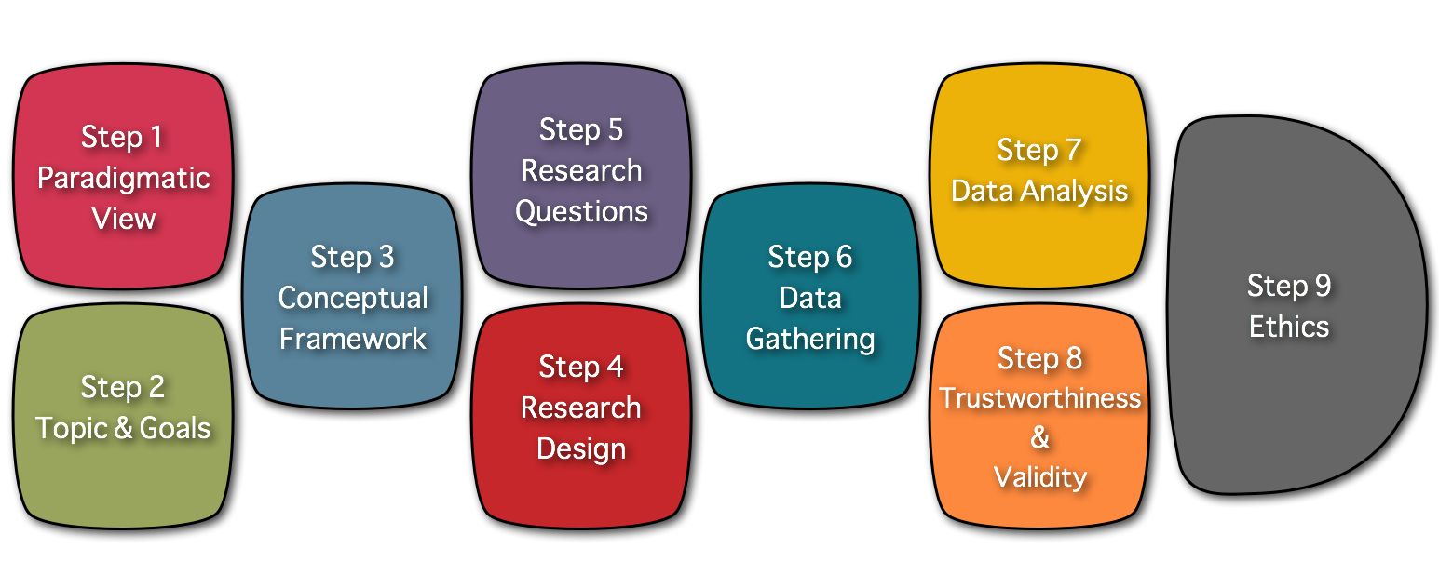

Personal Data
Name: <<Name>>
email: <<email>>
Date: <<Date>>

Step 1: Paradigmatic View of the Researcher
The Worldview you will be bringing to the study is: <<How would you define your Worldview?>>

Step 2: Topic & Goals of your study
Description of your Research Topic: <<Research Topic>>

Personal goals driving your study: <<Please describe the personal goals that drive you to conduct this study>>

Practical goals driving your study: <<Please describe the practical goals that drive you to conduct this study>>

Intellectual goals driving your study: <<Please describe the intellectual goals driving you to conduct this study>>

Step 3: Conceptual Framework of your study
Topical Research: <<Topical Research >>

Gaps identified in the field: <<Gaps identified in the field>>

Theoretical Frameworks: <<Theoretical Frameworks>>

Problem Statement: <<Problem Statement>>

Step 4: Research Design
The Research Design you will be using is:
<<Which mixed-methods research design works better for the study you have in mind? >>

The structure of your study will be:
<<Which research design will be predominant in your embedded mixed methods study? >>

Quantitative portion of the study
<<Which research design will you use for the quantitative piece of your Convergent parallel mixed methods study? >>
<<Stage 1: Which research design will you use for the quantitative piece of your explanatory sequential mixed methods study? >>
<<Stage 2: Which research design will you use for the quantitative piece of your exploratory sequential mixed methods study? >>
<<Which quantitative research design will you employ in your embedded study? >>
Qualitative portion of the study
<<Which research tradition will you use for the qualitative piece of your Convergent parallel mixed methods study? >>
<<Stage 2: Which research tradition will you use for the qualitative piece of your explanatory sequential mixed methods study? >>
<<Stage 1: Which research tradition will you use for the qualitative piece of your exploratory sequential mixed methods study? >>
<<Which qualitative research tradition will you employ in your embedded study? >>

Link to the Visual representation of your <<Which mixed-methods research design works better for the study you have in mind? >> study : <<Visual representation>>

Step 5: Research Questions
Research Question driving the quantitative portion of your study:
<<Please include below the research question driving the quantitative portion of your study. >>

Research Question driving the qualitative portion of your study:
<<Please include below the research question driving the qualitative portion of your study. >>

Step 6: Data Gathering Methods
The data Gathering Methods you will be using in the quantitative portion of your study are: <<Which data gathering methods will you use in the quantitative portion of your your study>>

The data Gathering Methods you will be using in the qualitative portion of your study are:
<<Which data gathering methods will you use in the qualitative portion of your your study>>

Step 7: Data Analysis Methods
The data Analysis Methods you will be using in the quantitative portion of your study are: <<Please define the analysis methods you will use in the quantitative portion of your study>>

The data Analysis Methods you will be using in the qualitative portion of your study are:
<<Please define the analysis methods you will use in the qualitative portion of your study>>

Step 8: Validity & Trustworthiness
The strategies you will use to control the validity and reliability of your study are: <<Which are the strategies you will use to control the validity of the quantitative portion of your study?>>

The strategies you will use to ensure the trustworthiness of your study are:
<<Which are the strategies you will use to ensure the trustworthiness of the qualitative portion of your study?>>

Step 9: Ethical principles driving your study
The ethical principles that will be driving your study are : <<Which major ethical principles will drive your study?>>

Visual Representation of your Conceptual Framework

Research Topic
<<Research Topic>>

Topical Research |  | Theoretical Frameworks
<<Topical Research >> |  | <<Theoretical Frameworks>>
Gaps identified in the field
<<Gaps identified in the field>>
Problem Statement
<<Problem Statement>>
Research Questions
Research Question driving the quantitative portion of your study: <<Please include below the research question driving the quantitative portion of your study. >>

Research Question driving the qualitative portion of your study: <<Please include below the research question driving the qualitative portion of your study. >>
Research Design
<<Which mixed-methods research design works better for the study you have in mind? >>
<<Visual representation>>

